

VITyarthi-Evaluated Course Project
Python Essentials

Project Title: ATM Management System
Academic year:2026-27

Submitted By:
Ritik Raj
26BAI10303
School of Computer Science Engineering And Artificial Intelligence (SCAI)
B.tech- Computer Science Enginnering(AI & ML)
Introduction
The ATM Management System Using Python is a console-based app made with the Python programming language. This project mimics how a real Automated Teller Machine (ATM) works.
Users can check their account balance withdraw money, deposit money and see their transaction history. Before allowing a withdrawal the system asks for a PIN to confirm the user’s identity.
This project shows Python concepts, like variables, functions, if-else statements, loops, lists taking input from users and handling basic data. It’s a hands-on way to learn how to build a working program.

Problem Statement
In a banking environment customers often need to do simple tasks like checking their account balance putting money in taking money out and looking at past transactions.
This project aims to create an ATM simulation that lets users do these tasks using a simple menu. The system will let users:

- Check their account balance.
- Verify their PIN before allowing a withdrawal.
- Withdraw money only if there is money in the account.
- Deposit money, into their account.
- Keep track of every transaction that happens.
- Show a list of transactions.
- Offer a way to exit the system safely.
Objectives

- The objectives of ATM Management System include:

- To create an easy ATM simulation with the help of Python.

- To enable basic banking transactions through a menu.

- To use PIN verification before performing the withdrawal.

- To ensure that there is enough balance before proceeding with the withdrawal.

- To stop the transactions, involving invalid deposits or withdrawals.

- To store transaction history of the user.

- To learn working with functions and lists in Python language.

- To practice programming with decision-making and using the if-elif-else statements.

- To develop continuous interaction with the menu through a while loop.

- To enhance the skills related to programming.

Functional Requirements

Functional specifications indicate the capabilities of the system.

Balance Inquiry
The system has to enable the user to inquire about their balance.
Example:
Your current balance is: ₹ 10000

Cash Withdrawal

The system should provide the user with the opportunity to withdraw cash from their account.
Prior to performing a withdrawal, the system prompts the user for the PIN.
The system verifies the following:
- Is the PIN correct?
- Is the amount greater than zero?
- Is there enough balance?

Money Deposit

The system must provide to the user the opportunity to deposit money to the account.

The system verifies that the entered amount is positive.

Transaction History

The system must maintain and provide the user with the transaction history.
The transactions include:
- deposits
- withdrawals

Exit

The system should give the user an option to exit ATM application.

Non-Functional Requirements
The non-functional requirements explain how the system is required to function.

Usability

The system must be user-friendly and straightforward to navigate, allowing users to choose their preferences from the menu.

Reliability

The system must be able to adjust the balance accurately after every transaction.

Security

The system has a PIN authentication mechanism before the money can be withdrawn from the account.

Performance

The system performs all of the minor jobs quickly with the help of a small volume of data handled by the app.

Maintainability

There are several functions that the program has been divided into, which makes the understanding of the app straightforward.

Accuracy

The system is developed in a way that makes proper calculations of the balance after the operation.

Algorithms
Algorithm 1: Check Balance
- Start.
- Receive the current balance.
- Display the current balance.
- Return to the main menu.
Algorithm 2: Withdraw Money
- Initiate the withdrawal process.
- Prompt the user to input their PIN.
- Verify the provided PIN against the stored PIN.
- If the PIN is incorrect:
- Show a message saying, "PIN entered is not correct."
- Go the main menu.
- If the PIN is valid:
- Request the user to enter the amount to withdraw.
- Confirm that the amount is more than zero.
- If the amount does not meet the requirement, display an error message.
- Confirm that the amount is lower than the available balance.
- If it does not, show an error message.
- Otherwise, deduct the amount from the available balance.
- Include the transaction into the list of transactions.
- Indicate the amount remaining in the account.
Algorithm 3: Deposit Money
- Begin deposit operation.
- Request user to input the deposit amount.
- Verify if the input amount is greater than zero.
- If the amount is not valid, show an error message.
- If the amount entered is valid, then add the amount to balance.
- Please make sure you add the deposit to the record of transactions.
- Finally show the updated balance.

Algorithm 4: Transaction History
- Initiate the operation for transaction history.
- Check whether the transaction list has no transactions.
- If the transaction list is empty, {print "No transactions found."} otherwise print each transaction from the transactions list.
- Return to the main menu.

Work Flow
The overall workflow of the ATM system is:

START
↓
Display ATM Menu
↓
Enter User Choice
↓
┌───────┴────────┐
↓ ↓
Check Balance Withdraw Money
↓ ↓
Display Balance Verify PIN
↓
Check Amount
↓
Check Available Balance
↓
Update Balance
↓
Save Transaction
┌────────────────┼───────────────┐
↓ ↓ ↓
Deposit Transaction Exit
Money History ↓
↓ ↓ END
Update Balance Display Records
↓ ↓
└────────────────┴──→ ATM Menu

The program continuously displays the ATM menu because it uses a while True loop. The loop ends when the user selects option 5 (Exit).

Case Diagram
The main actor in the system is the User.

+---------------------------+
| ATM MANAGEMENT |
| SYSTEM |
| |
User ─────────────►| Check Balance |
| |
User ─────────────►| Withdraw Money |
| ↓ |
| Verify PIN |
| |
User ─────────────►| Deposit Money |
| |
User ─────────────►| View Transaction History |
| |
User ─────────────►| Exit System |
+---------------------------+

User: The user communicates with the ATM machine to carry out some banking processes like finding out the account balance, taking out money, putting in money, and seeing the history of transactions.

Use Cases
Find Out the Account Balance
Withdraw Money
Deposit Money
See Transaction History
Log off

Implementation Details

The project is implemented using Python.
Variables
The program uses variables to store important information:

balance = 10000
pin = "1234"
transactions = []

- balance stores the current account balance.
- pin stores the user's PIN.
- transactions stores transaction records.

Functions

The project uses separate functions for different operations.
check_balance()
Displays the current balance.
def check_balance(balance):
print("\nYour current balance is: ₹", balance)

withdraw_money()

Manages PIN checking, validation of the withdrawal sum, checking of the balance, and keeping track of the transaction information.

deposit_money()

Takes care of deposits and changes the balance of the account accordingly.

transaction_history()

Shows all of the transactions that are recorded in the transaction list.

Conditional Statements:

The program employs if, elif, and else statements to make decisions.
For example:
if amount > balance:
print("Insufficient balance.")

Loop
A while True loop is used to repeatedly display the ATM menu.
while True:
The loop terminates when the user selects option 5.
List
A Python list is used to store transaction records:
transactions = []
New transactions are added using:
transactions.append(...)

Learnings
- As a result of this project, I acquired knowledge of the following concepts:
- Variables in Python
- I learned how data is stored and manipulated by means of variables.
- Functions
- I learned how to divide the program into smaller and reusable components.
- Conditional Statements
- I learned how to make decision making with the help of if, elif, and else.
- Loops
- I learned how to repeat the process of displaying the ATM menu using the while loop.
- Lists
- I learned how to use a list in Python to store multiple transaction records.
- User Input
- I learned how to gather data from users with the help of the input() function.
- Data Validation
- I learned how to check whether the specified amounts are incorrect and if there are sufficient funds in the account.
- PIN Validation
- I learned how to perform authentication using a PIN.
- Problem-solving
- I learned how to turn real life operation of an ATM into programming logic.
- Program Structure
- I learned how to use all the mentioned concepts in a single program.

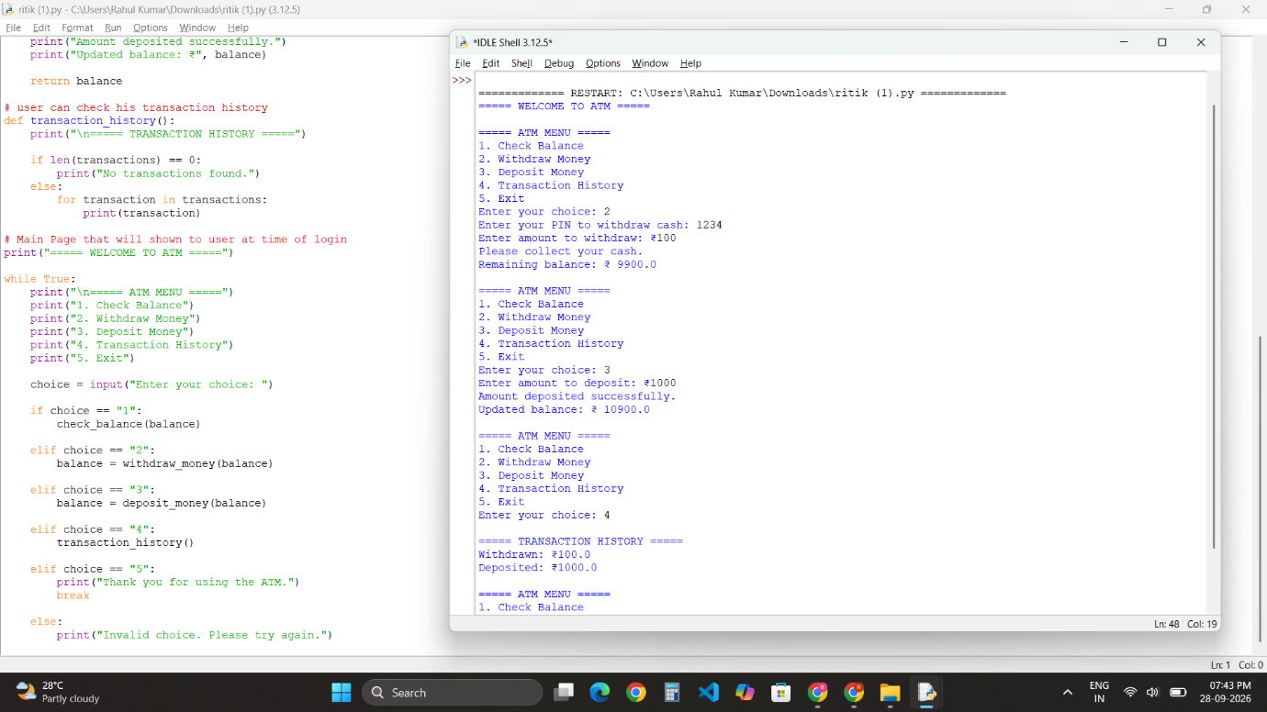

Conclusion
The ATM Management System Using Python successfully demonstrates the basic functionality of an ATM through a simple console-based application. The system allows users to check their balance, withdraw money, deposit money, and view transaction history.
The project provides practical experience with important Python concepts such as functions, loops, conditional statements, lists, user input, and data validation.
Although this is a basic simulation and does not use a real bank database or banking network, it provides a strong foundation for understanding how an ATM system can be designed and implemented using programming concepts.

